WEEK 1 PRACTICAL
TASK 1
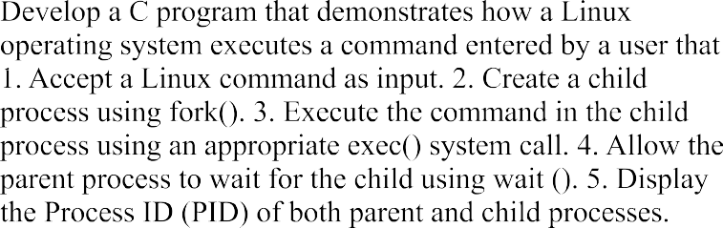

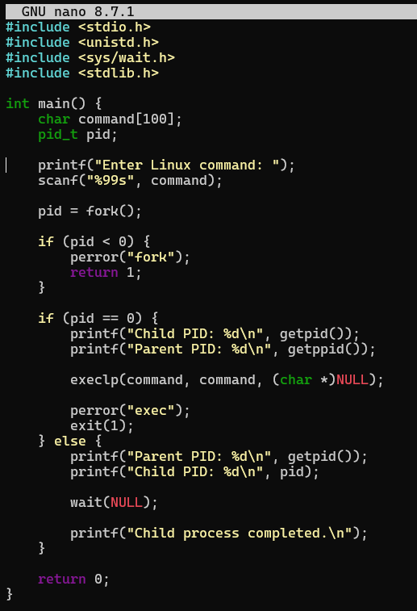

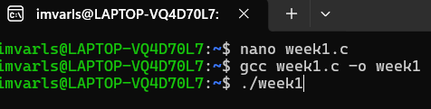
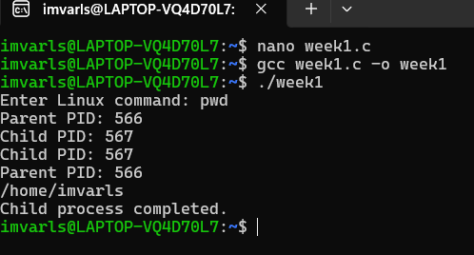

Task2
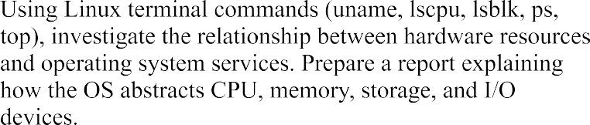

- Uname: Displays operating system and kernel information.
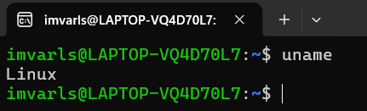

lscpu: Displays CPU information.

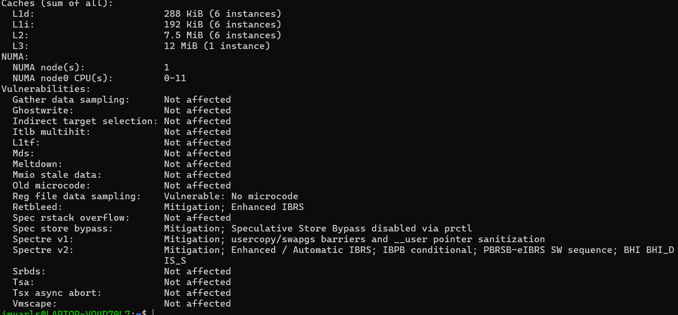

lsblk: Displays storage devices.
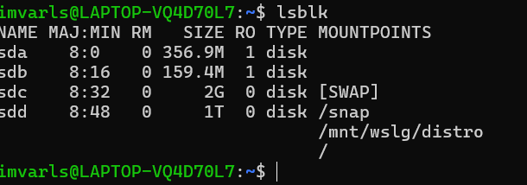

ps: Displays currently running processes.
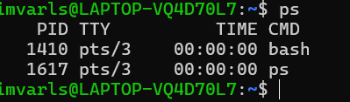

top: Displays real-time system performance.

